Lincoln County BOCC Economic Development Budget (2019 – 2026)
Budgets (under HSERV Tab):
2019/2020
HUMAN SERVICES | 2016-2017 | 2015-2016 | 2017-2018 | 2017-2018 | 2018-2019 | 2019-2020 | 2019-2020
 | BUDGET | ACTUAL | BUDGET | ACTUAL | BUDGET | REQUEST | FINAL
9126-30 W.W. COLLEGE ABE | $ 5,000.00 | $ 5,000.00 | $ 5,000.00 | $ 5,000.00 | $ 5,000.00 | $ 5,000.00 | $ 5,000.00
9130-30 THAYNE FIRE DEPT. | $ 30,000.00 | $ 30,000.00 | $ 30,000.00 | $ 30,000.00 | $ 30,000.00 | $ 35,000.00 | $ 28,000.00
9132-30 LABARGE FIRE DEPT. | $ 26,000.00 | $ 26,000.00 | $ 26,000.00 | $ 26,000.00 | $ 26,000.00 | $ 31,000.00 | $ 26,000.00
9166-30 L.C. ECONOMIC DEV. | $125,000.00 | $ 76,210.00 | $100,000.00 | $102,387.50 | $ 100,000.00 | $ 100,000.00 | $ 100,000.00
9168-30 NO LINC HUMAN RESOURCE COUNCIL | $ 1,000.00 | $ 1,000.00 | $ 1,000.00 | $ 1,000.00 | $ 1,000.00 | $ 1,000.00 | $ 1,000.00
9169-30 WWCC - SV OUTREACH | $ 3,000.00 | $ 3,000.00 | $ 3,000.00 | $ 3,000.00 | $ 3,000.00 | $ 3,000.00 | $ 3,000.00
2021/2022 (pg 40):
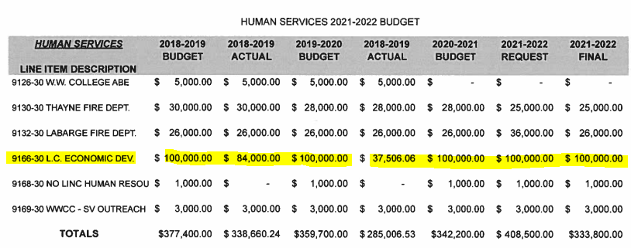
2022/2023 (pg 41)
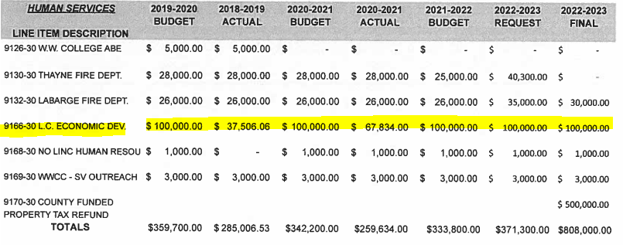
2023/2024 (pg 43)
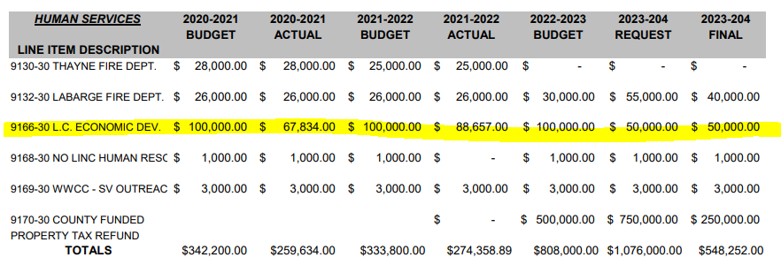
2024/2025 (pg 43)
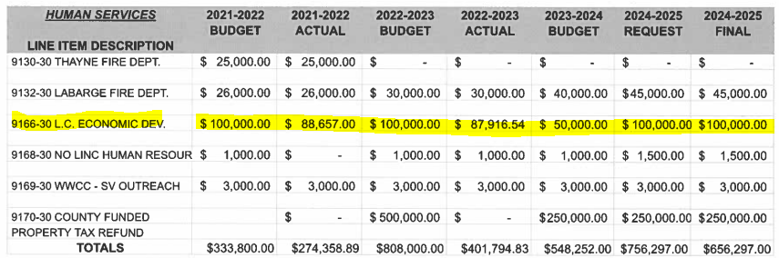
Final Budget 2025/ 2026 (pg 38)
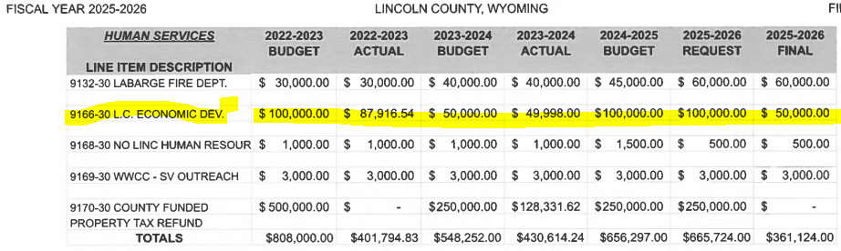

Tri-Sight
Evaunt
Criterium
WAHKE
Rex Harvey Vaughan
CRS Engineering
EnergyComm Consulting – Sharon Fain

